Year 2 – Multiplication and Division
Helping your child at home with Maths
Children’s numeracy skills can be greatly boosted by help at home, in the same way that regular help with spelling and reading can nurture their literacy skills. Parents are often nervous to help in maths however, worried they may confuse their child by teaching them ‘different’ methods (“we didn’t do it like this in my day…”!). At Elmlea, we aim to teach children to work with number in lots of different ways. We know that what works for one child will not always make sense to another and that by giving them a range of different methods and teaching approaches your child will have a good understanding of the mathematical concepts.
Your child will probably understand the maths more by ‘seeing’ it first of all, so we tend to start by introducing maths concepts in a very practical, concrete way (using practical apparatus such as counters to manipulate). We then move to pictorial concepts, so the children see the maths in a visual way before moving to the abstract recorded maths.
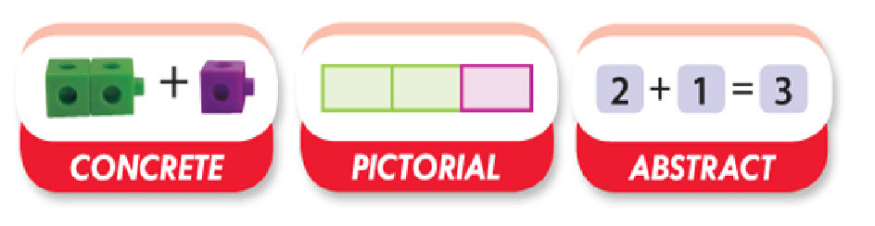
Each term we will be focussing on a different maths theme or concept. This ensures that the children have a deep understanding or mastery of that element before moving onto a new concept.
This booklet will give you an overview of the objectives taught, examples of the methods used and activities and games you can play at home to help your child become secure in these objectives.

Multiplication and Division
By the end of Year 2 your child should be able to:
- recall multiplication and division facts for 2, 5 and 10 and use them to solve simple problems, demonstrating an understanding of commutativity as necessary
Vocabulary used
All vocabulary taught at KS1 will be used throughout their schooling so it is important that they are clear on all definitions.
- Multiply, times, groups of, lots of – These are interchangeable
- Divide, share, groups of
- Half
- Fraction
- Array
- Numberline
- Equal
- Repeated addition
This booklet will now take you through the objectives that will be taught in Term 3 and examples of the methods used. After each section there will be some activities and games which will help the children consolidate their learning. It is expected that they do at least one activity a week.
Times Tables
A good foundation in their 2, 5 and 10 times tables will help your child with multiplication and division. We will teach them a range of strategies, detailed below, that will support them when they are unsure. However, an ability to use and apply their times tables will be the most efficient strategy when faced with either a multiplication or division problem.
Times tables are a big focus throughout your child’s school life and they will be assessed on them in Year 4.
At Elmlea we learn the times tables in this order:
- 10
- 2
- 5
In class we learn the times tables by rote ie. chanting and singing but we also present them in different ways so the children begin to see them in isolation. For example, we phrase them in a variety of ways:
- “7 times 2”
- “2 times 7”
- “7 lots of 2”
- “2 lots of 7”
- “2 multiplied by 7”
- “7 multiplied by 2”
- “2 groups of 7”
- “7 groups of 2”
- “How many 2s are there in 14?”
All of these are different ways to help learn 7 x 2.
When we begin to learn about division we bring the children’s attention to the inverse ie. 15 divided by 5 – we know that 3 x 5 is 15 so the answer must be 3.
Ways to help with times tables at home
- Display the relevant times tables in your home so your child can get used to seeing them
- Use a spare 2 minutes in the day to quiz them on a couple of random questions they already know
- A stack of coins – at least a dozen each of 2p, 5p and 10p will let you make up a full set of tables to 12x12 for the occasions when your child might need to go back and check by counting. No cost, beyond the time it takes to collect up the change.
- A pack of cards – take out the aces and Kings, count Jack as 11 and Queen as 12, and you can practise the full range of tables by dealing your child two cards and asking them to multiply them.
Online activities:
https://www.topmarks.co.uk/maths-games/hit-the-button
https://www.youtube.com/watch?v=iiR8hqJeQsw
Arrays
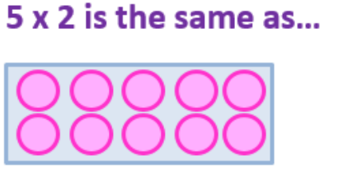
An array is formed by arranging each set of objects in to rows and columns. Each column must contain the same number of objects as the other columns and each row must have the same number as the other rows.
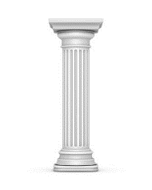

It helps the children to think of columns as
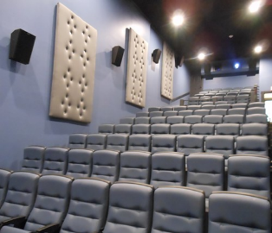

and rows as chairs in a cinema.
Arrays help children visualise the multiplication calculation they have been presented with. For example, 5 x 4 =
We would then encourage the children to count in 5s rather than 1s to work out the answer.
Ways to help with arrays at home
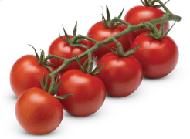
- They are everywhere! You can spot arrays in the real world and ask children to find the calculation or answer. For example,
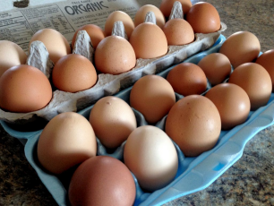

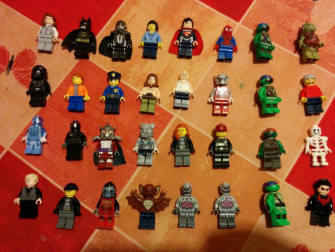
- Counters, coins, toys etc. can all be placed in arrays for your child to solve.

Online resources:
http://education.abc.net.au/home#!/media/1496767/the-array
Multiplication on a numberline
Multiplication can be thought of as repeated addition. For example, 3 x 5 can be thought of as 5 + 5 + 5 = ?. This can be shown on a numberline like this :
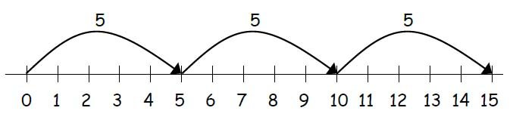
It is good for children to see different ways of representing calculation so
3 x 5 = 5 + 5 + 5 = 5 x 3 = 3 + 3 + 3 +3 +3
Division by sharing
Often children’s first experience of division is the idea of ‘sharing’. However, be careful! If you are ‘sharing’ at home it may not be totally equal whereas sharing in division must be into equal groups.
The children start by sharing out real objects.
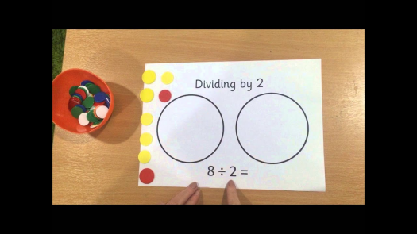
They then begin to draw circles and share the dots between them to help them solve division calculations.

Division by grouping
Another way the children can visualise division is by grouping. To do this the children draw an array and then ‘group’ the dots.
For example, 10 divided by 2
- The children draw 10 dots in rows of 5
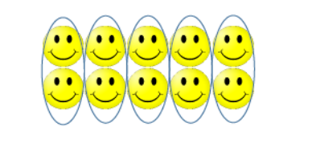
- They can then circle the groups of 2 to find out how many groups

So the answer is 10 divided by 2 = 5
Link to fractions
We begin to introduce the concept of fractions alongside division. For example, if we are dividing something by 2 we will use the word ‘half’ and show them the correct symbol to show this.
Ways to help with division at home
- Sharing food/toys/counters equally
- In a similar way to making arrays – line up objects to group for division calculations
Online resources:
https://www.ictgames.com/mobilePage/doggyDivision/index.html
https://www.topmarks.co.uk/maths-games/hit-the-button
If you or your child are unsure about anything covered in this booklet, please let your class teacher know.

