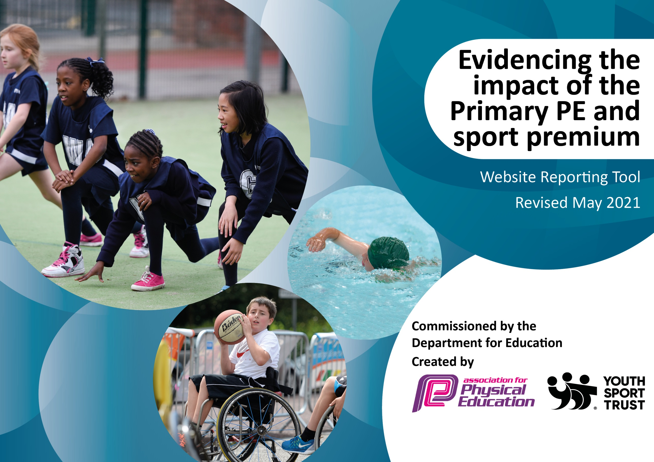

It is important that your grant is used effectively and based on school need. The Education Inspection Framework (Ofsted 2019 p64) makes clear there will be a focus on ‘whether leaders and those responsible for governors all understand their respective roles and perform these in a way that enhances the effectiveness of the school’.

Under the Quality of Education criteria (p41) inspectors consider the extent to which schools can articulate their curriculum (INTENT), construct their curriculum (IMPLEMENTATION) and demonstrate the outcomes which result (IMPACT).

To assist schools with common transferable language this template has been developed to utilise the same three headings which should make your plans easily transferable between working documents.

Schools must use the funding to make additional and sustainable improvements to the quality of Physical Education, School Sport and Physical Activity (PESSPA) they offer. This means that you should use the Primary PE and sport premium to:

- Develop or add to the PESSPA activities that your school already offer
- Build capacity and capability within the school to ensure that improvements made now will benefit pupils joining the school in future years
- The Primary PE and sport premium should not be used to fund capital spend projects; the school’s budget should fund these.
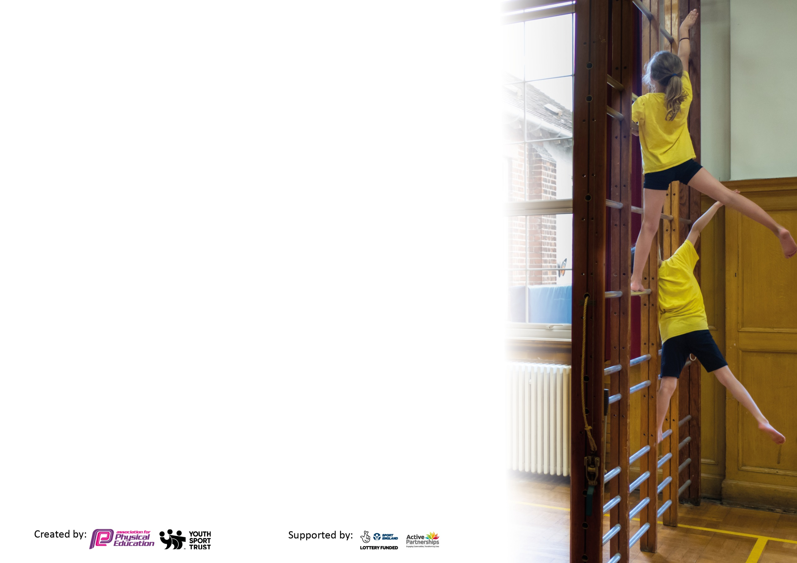
Please visit gov.uk for the revised DfE guidance including the 5 key indicators across which schools should demonstrate an improvement. This document will help you to review your provision and to report your spend. DfE encourages schools to use this template as an effective way of meeting the reporting requirements of the Primary PE and sport premium.

We recommend you start by reflecting on the impact of current provision and reviewing the previous spend.

Schools are required to publish details of how they spend this funding, including any under-spend from 2019/2020, as well as on the impact it has on pupils’ PE and sport participation and attainment by the end of the summer term or by 31st July 2021 at the latest.

We recommend regularly updating the table and publishing it on your website throughout the year. This evidences your ongoing self-evaluation of how you are using the funding to secure maximum, sustainable impact. Final copy must be posted on your website by the end of the academic year and no later than the 31st July 2021. To see an example of how to complete the table please click HERE.

Please note: Although there has been considerable disruption in 2020 it is important that you publish details on your website of how you spend the funding - this is a legal requirement.
Support for review and reflection - considering the 5 key indicators from DfE, what development needs are a priority for your setting and your pupils now and why? Use the space below to reflect on previous spend and key achievements and areas for development.

N.B. In this section you should refer to any adjustments you might have made due to Covid-19 and how these will influence further improvement.
Key achievements to date until July 2021: | Areas for further improvement and baseline evidence of need:
- Promotion of regular physical activity through installation of new  multi skill playground markings for children to use during PSHE active blasts, break and lunchtimes.  Maintain physical activity within key worker children during periods of lockdown through the use of specialist sport coaches. This not only allowed the children to continue to be physically active but also helped their mental health in having fun with other children during a particularly hard time. Launch of Wow Active Travel scheme to promote regular physical activity through walking, scooting or cycling to and from school.  2. Inspire and motivate children through a visit from Olympic Gold medallist Jason Gardener. He spoke to all the children about the motivation and resilience needed to become an Olympian and winning a gold medal and linked to working hard to achieve any goal the children may have.  3. Through using Get set for PE platform for schemes of learning and  lesson plans staff are confident to teach PE lessons and have a good knowledge base.  3/4. Implementation of new cross curricular orienteering scheme of learning. This included staff training, various maps and routes of the school and permanent markers. Children have enjoyed doing a new activity within lessons which has given them the skills to apply within a competitive environment.  4. Children have continued to have opportunities to take part in a range of sporting activities at lunchtimes with sports coaches who deliver sessions. A female coach during this time has inspired more girls to participate in these activities.  Specialist inclusion coaching for a group of children in Y6 to promote team work and self-esteem to assist transition into secondary school.  Established club link with Henleaze tennis club to assist in the delivery of after school clubs.  5. Participation in a number of virtual personal best competitions against other schools during lockdowns.  Whole school participation in house sports days. | 1/3. Staff and child training on the multi skill playground markings in order to continue to promote regular physical activity during brain breaks throughout the day, PSHE active morning sessions, break and lunchtimes. Children to lead activities on the markings as part of personal challenges and house inter competition. Continue to promote active travel through the use of the Wow initiative and focus on families using the ‘park and stride’ option to park further away from the school site to then stride further into school increasing their active travel. Roll out of activity journals for all children to record their physical activity within and out of school.  2. Invite parents/relatives who are athletes into school to inspire children to participate in sports. Nominate a captain from each team representing the school in competitions to write a match report to be read during assemblies.  3. Time for PE lead to team teach with other staff working on specific areas of development identified. PE lead provide in house staff CPD on general areas of need as identified in PE staff voice. Opportunities for staff to watch PE lead in areas they are interested in to support their own delivery within PE lessons.  4. Continue to work with SEND specialist in shaping curriculum activities to allow all children an opportunity to access the PE curriculum. This will also allow further opportunities for participation competition within a range of activities without apprehension. Continued use of the ‘get set for PE’ platform to allow progression of skills and knowledge of a range of sports from lower school to upper school through introduction of new activities. Organise and assist in maintaining a low cost to parents for children to take part in outdoor adventurous activities within Mojo. Establish club links with local sports clubs to allow children the confidence to take part in club sport outside of the school grounds. Club links will also assist in the delivery of after school clubs.  5. Take part in inter sport competitions against other schools in a range of activities and abilities to allow a range of children the opportunity to represent the school in school sport. Appoint PE monitors and liaise with them to identify termly intra house school competitions which they will take lead in organising and running.

Did you carry forward an underspend from 2019-20 academic year into the current academic year?
YES * Delete as applicable
Total amount carried forward from 2019/2020 £5,289.80
+ Total amount for this academic year 2020/2021 £19,500.00
= Total to be spent by 31st July 2021 £24,789.80

Meeting national curriculum requirements for swimming and water safety.

N.B Complete this section to your best ability. For example you might have practised safe self-rescue techniques on dry land which you can transfer to the pool when school swimming restarts.
Due to exceptional circumstances priority should be given to ensuring that pupils can perform safe self rescue even
if they do not fully meet the first two requirements of the NC programme of study.
What percentage of your current Year 6 cohort swim competently, confidently and proficiently over a distance of at least 25 metres?  N.B. Even though your pupils may swim in another year please report on their attainment on leaving primary school at the end of the summer term 2021.  Please see note above. | 96%
What percentage of your current Year 6 cohort use a range of strokes effectively [for example, front crawl, backstroke and breaststroke]?  Please see note above. | 85%
What percentage of your current Year 6 cohort perform safe self-rescue in different water-based situations? | 66%
Schools can choose to use the Primary PE and sport premium to provide additional provision for swimming but this must be for activity over and above the national curriculum requirements. Have you used it in this way? | No

Action Plan and Budget Tracking
Capture your intended annual spend against the 5 key indicators. Clarify the success criteria and evidence of impact that you intend to measure to evaluate for pupils today and for the future.

Academic Year: 2020/21 | Total fund allocated: £24,789.80 | Date Updated: 15.07.2021
Key indicator 1: The engagement of all pupils in regular physical activity – Chief Medical Officers guidelines recommend that primary school pupils undertake at least 30 minutes of physical activity a day in school |  |  |  | Percentage of total allocation:
 |  |  |  | 39%
Intent | Implementation |  | Impact
Your school focus should be clear what you want the pupils to know and be able to do and about  what they need to learn and to  consolidate through practice: | Make sure your actions to achieve are linked to your intentions: | Funding allocated: | Evidence of impact: what do pupils now know and what can they now do? What has changed?: | Sustainability and suggested next steps:
Promotion of regular physical activity.  Maintain physical activity within key worker children during periods of lockdown.  Launch of Wow Active Travel scheme.  To ensure all children have the opportunity to participate in at least 30minutes of physical activity through organised activities at lunchtime. | Installation of new multi skill playground markings for children to use during PSHE active blasts, break and lunchtimes.  Through the use of specialist sport coaches during lockdown within school for key worker children.  Promote regular physical activity through walking, scooting or cycling to and from school.  Provide 2 specialist sports coaches to lead sporting activities for children to take part in. NB increase from last year due to two lunch breaks in line with Covid-19 restrictions. | £3598.80  £5,900  £0  (due to our first year of participation)  £5,964.50 | Children are using the playground markings in their own time during break and lunchtimes. PE lead has taught some games to the children to play but also children have created their own games.  This not only allowed the children to continue to be physically active but also helped their mental health in having fun with other children during a particularly hard time.  Allowed children and families an opportunity to consider their travel choices to and from school. Children enjoy receiving their badges of achievement.  Children have really enjoyed taking part in a range of activities with the coaches again. This year a female coach has inspired and motivated more girls to take part in these activities. | Staff to receive training on the use of the playground markings for whole class participation during PSHE active time and active blasts. PE monitors also receive training on how to lead activities for other children as personal best challenges at lunchtimes.  Children were more confident to take part in coach lead physical activities when school re-opened.  Continue to promote active travel to families through the use of a park and stride sight.  2 sports coaches for 2 lunchtimes a week, and 1 coach for 3 days a week. The PE lead will deliver sports activity sessions in place of the second external coach.
Key indicator 2: The profile of PESSPA being raised across the school as a tool for whole school improvement |  |  |  | Percentage of total allocation:
 |  |  |  | 6%
Intent | Implementation |  | Impact
Your school focus should be clear what you want the pupils to know and be able to do and about  what they need to learn and to  consolidate through practice: | Make sure your actions to achieve are linked to your intentions: | Funding allocated: | Evidence of impact: what do pupils now know and what can they now do? What has changed?: | Sustainability and suggested next steps:
Inspire and motivate children how taking part in sport and physical activity can help achieve goals.  Cross curricular orienteering scheme of learning and courses.  Inclusion of personal challenge and virtual athletics competitions within celebration assemblies. | A visit from Olympic Gold medallist Jason Gardener and sponsored activity circuit. He spoke to all the children about the motivation and resilience needed to become an Olympian and winning a gold medal and linked to working hard to achieve any goal the children may have.  This includes staff training, various maps and routes of the school and permanent markers. Once children have been taught the skills of orienteering staff can use the various curriculum markers as an active way to reinforce learning across curriculum areas.  One slide of Friday’s celebration assembly dedicated to those children who had achieved best scores in sporting competitions. | £0  (£535.50 fund raising event)  £1,395  £0 | The children really enjoyed their slot completing a circuit with a commonwealth Gold medallist and then hearing from Jason and his motivational story.  Children have enjoyed doing a new activity within lessons which has given them the skills to apply within a competitive environment. Math’s courses have been used within STEM week as a good start to using orienteering across the curriculum.  Children feel proud to have their hard work recognised in front of others which motivates others to take part. | Jason’s story linked well to our own sports day which hopefully continue to inspire and motivate children to try their best.  Stagger the lessons across the year groups as a recap of orienteering skills at the start of the year. Children will then be equipped with the skills to be able to apply when using cross curricular markers during the remainder of the year.  Continue to celebrate success from school sport but also create a platform for children to inform PE lead of sport success outside of school which can also be celebrated.

Key indicator 3: Increased confidence, knowledge and skills of all staff in teaching PE and sport |  |  |  | Percentage of total allocation:
 |  |  |  | 2%
Intent | Implementation |  | Impact
Your school focus should be clear | Make sure your actions to | Funding | Evidence of impact: what do | Sustainability and suggested
what you want the pupils to know | achieve are linked to your | allocated: | pupils now know and what | next steps:
and be able to do and about | intentions: |  | can they now do? What has
what they need to learn and to |  |  | changed?:
consolidate through practice:
Ensure high quality PE provision during curriculum lessons for non-specialists.  Staff training on new playground markings. | Continued subscription to Get Set for PE platform which provided progressive schemes of learning and lesson plans.  Staff to receive training on games and activities to deliver using the new multi sport playground markings for whole classes. | £296  £0  (as part of installation fee) | Staff feedback questionnaires identified the lesson plans are easy to follow and are user friendly. They are confident in delivering a range of activities within their PE lessons. Many children have also taken part in activities over lockdown at home.  Unfortunately training was unable to be booked due to time constraints of staff. | Schemes of learning and lesson plans have been saved and printed in packs for each staff member to use for their lessons year on year.  Training to be delivered in term 1 2021.
Key indicator 4: Broader experience of a range of sports and activities offered to all pupils |  |  |  | Percentage of total allocation:
 |  |  |  | 14%
Intent | Implementation |  | Impact
Your school focus should be clear | Make sure your actions to | Funding | Evidence of impact: what do | Sustainability and suggested
what you want the pupils to know | achieve are linked to your | allocated: | pupils now know and what | next steps:
and be able to do and about | intentions: |  | can they now do? What has
what they need to learn and to |  |  | changed?:
consolidate through practice:
Inspire children to take part in a broad range of activities.  Specialist inclusion coaching for a group of children in Y6 to promote team work and self-esteem.  Establish club links to assist in specialist delivery of sessions.  Provide top-up lessons for children who have missed out on opportunities to swim 25m or demonstrate water safety.  Provide good quality and adapted equipment suited to the needs of all children.  All children to re-connect with each other through team work based OAA activities at Mojo. | Olympic sport taster sessions in celebration of The 2021 Olympic Games. These to include skateboarding, taekwondo and golf.  Collaborating with the SENDCO and class teachers a small group of Y6 children were selected to receive coaching in a physical activity designed to help improve their confidence and self-esteem before their transition to secondary school.  Club link created with Henleaze Lawn Tennis Club. Head coach to lead sessions during after school tennis club.  Working with Bristol Penguins in delivering specialist swimming coaching for Y6 children who have yet to swim 25m or demonstrate water safety.  Purchase of new equipment to continue to implement new schemes of learning. Replace damaged equipment ready for safe use.  Work with Mojo to come up with fun OAA activities that promote collaboration and teamwork so children can re-connect with each other coming out of lockdown. | £0  (£1,300)  £0  (£500)  Working in partnership with The Bristol Sport Foundation a coach provided sessions free of charge.  £70  £0  (£500)  £3,500  £0  (£800) | Unfortunately, all activities were cancelled due to Covid 19 cases.  The selected children had enjoyed their ‘VIP’ sessions which allowed them to be play in a physical activity with the confidence of being with other children of similar ability and mind set.  Children have really benefited from the coach’s knowledge and experience and have progressed in their skills. From participating in sessions with him children are motivated and confident to continue tennis within Henleaze club junior sessions.  Unfortunately, the lessons that were organised were cancelled due to multiple staff and child isolations.  Children are motivated to use new and different equipment which increases participation in physical activity.  Unfortunately we were unable to organise these visits due to Covid restrictions and Mojo availability. | Organise new sport taster sessions to allow all children an opportunity to experience new sports.  Continue to work with Bristol Sport Foundation to develop the PE curriculum to include activities that can be accessed by all children.  Henleaze to run an external tennis after school club for children across the school. This will provide a transition from after school to club level sport.  Continue to work with Bristol Penguins to establish specialist swimming teaching to those in need for Y6.  Set aside specific equipment for use at lunchtimes and break times in order to ensure curriculum PE equipment lasts longer.  Collaborate with Mojo to allow the lowest cost to parents moving forward to next academic year with 1 visit to co-inside the OAA programme of orienteering being delivered by teachers.

Key indicator 5: Increased participation in competitive sport |  |  |  | Percentage of total allocation:
 |  |  |  | 0%
Intent | Implementation |  | Impact
Your school focus should be clear | Make sure your actions to | Funding | Evidence of impact: what do | Sustainability and suggested
what you want the pupils to know | achieve are linked to your | allocated: | pupils now know and what | next steps:
and be able to do and about | intentions: |  | can they now do? What has
what they need to learn and to |  |  | changed?:
consolidate through practice:
Participation in a number of virtual personal best competitions against other schools during lockdowns.  Whole school participation in house sports days. | Regular personal best challenges launched remotely as part of the school games framework. Participation within a school games athletics competition against other schools. | £0 | Children have posted their personal challenge results and have enjoyed taking part in some kind of competition during periods of lockdowns and isolations. | Children are motivated by the personal challenge competition format. This will be a feature of intra competition next year.

Signed off by
Head Teacher: | Lorraine Wright
Date: | July 2021
Subject Leader: | Hannah Paterson
Date: | 15.07.2021
Governor: | Kevin Williamson
Date: | July 2021

