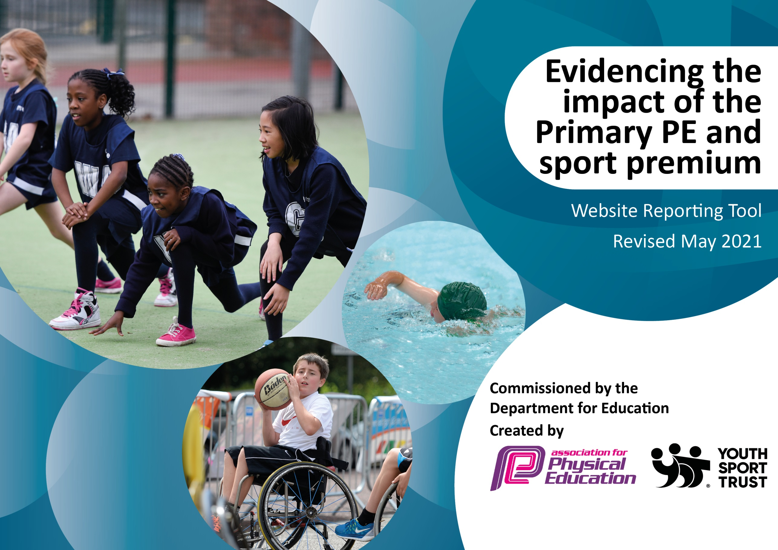

It is important that your grant is used effectively and based on school need. The Education Inspection Framework (Ofsted 2019 p64) makes clear there will be a focus on ‘whether leaders and those responsible for governors all understand their respective roles and perform these in a way that enhances the effectiveness of the school’.

Under the Quality of Education criteria (p41) inspectors consider the extent to which schools can articulate their curriculum (INTENT), construct their curriculum (IMPLEMENTATION) and demonstrate the outcomes which result (IMPACT).

To assist schools with common transferable language this template has been developed to utilise the same three headings which should make your plans easily transferable between working documents.

Schools must use the funding to make additional and sustainable improvements to the quality of Physical Education, School Sport and Physical Activity (PESSPA) they offer. This means that you should use the Primary PE and sport premium to:

- Develop or add to the PESSPA activities that your school already offer
- Build capacity and capability within the school to ensure that improvements made now will benefit pupils joining the school in future years
- The Primary PE and sport premium should not be used to fund capital spend projects; the school’s budget should fund these.
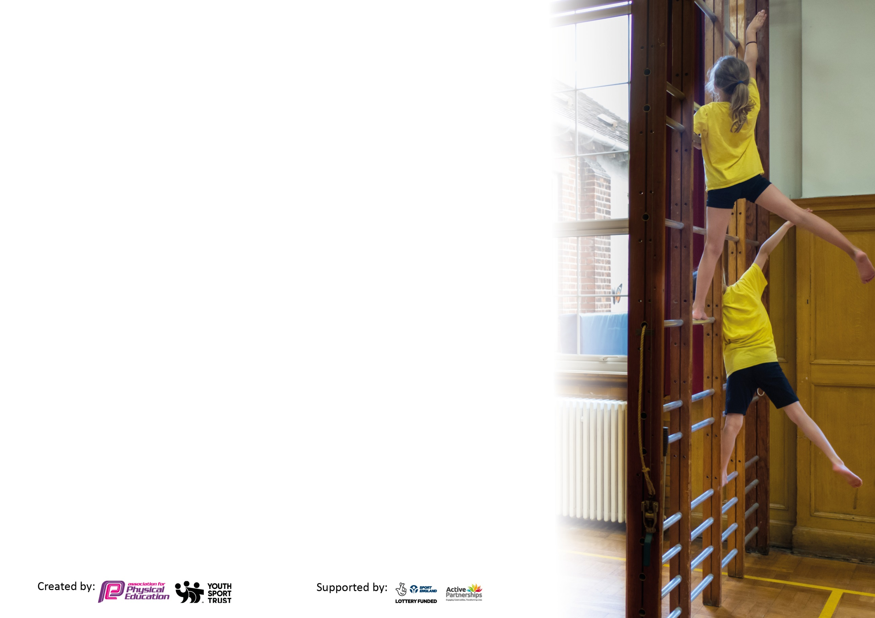
Please visit gov.uk for the revised DfE guidance including the 5 key indicators across which schools should demonstrate an improvement. This document will help you to review your provision and to report your spend. DfE encourages schools to use this template as an effective way of meeting the reporting requirements of the Primary PE and sport premium.

We recommend you start by reflecting on the impact of current provision and reviewing the previous spend.

Schools are required to publish details of how they spend this funding, including any under-spend from 2019/2020, as well as on the impact it has on pupils’ PE and sport participation and attainment by the end of the summer term or by 31st July 2021 at the latest.

We recommend regularly updating the table and publishing it on your website throughout the year. This evidences your ongoing self-evaluation of how you are using the funding to secure maximum, sustainable impact. Final copy must be posted on your website by the end of the academic year and no later than the 31st July 2021. To see an example of how to complete the table please click HERE.

Please note: Although there has been considerable disruption in 2020 it is important that you publish details on your website of how you spend the funding - this is a legal requirement.
Support for review and reflection - considering the 5 key indicators from DfE, what development needs are a priority for your setting and your pupils now and why? Use the space below to reflect on previous spend and key achievements and areas for development.

N.B. In this section you should refer to any adjustments you might have made due to Covid-19 and how these will influence further improvement.
Key achievements to date until July 2020: | Areas for further improvement and baseline evidence of need:
Positive whole school staff meeting identifying the importance of delivering high quality of PE on a regular basis. Reviewing current schemes of learning identifying what staff find easier to use and implement practically during their lessons. Positive feedback from staff showed they felt more confident about key points which make PE a positive experience for children and inspired them to make a difference. New schemes of learning for PE have now been provided across all activity areas for teachers to access both electronically and physically.  Children very engaged in their learning and have remained enthusiastic about their PE despite having such a strange year with lockdowns and having so much time out of school.  Club uptake has been excellent this year and children have enjoyed the wide variety of sports clubs available to them.  Lunchtime provision to ensure the 30 minutes of active time are met. | Consistency across the trust needs to be developed in order to give children good progression throughout their Primary education and to ensure teachers are clear on their goals and progression of lessons.  Access to specialist coaches can be improved in line with the revised curriculum in order to inspire children, especially in sports which are less common to experience during Primary education.

Did you carry forward an underspend from 2019-20 academic year into the current academic year? YES/NO * Delete as applicable
Total amount carried forward from 2019/2020 £10,145
+ Total amount for this academic year 2020/2021 £17,800
= Total to be spent by 31st July 2021 £27,945

Meeting national curriculum requirements for swimming and water safety.  N.B Complete this section to your best ability. For example you might have practised safe self-rescue techniques on dry land which you can transfer to the pool when school swimming restarts.  Due to exceptional circumstances priority should be given to ensuring that pupils can perform safe self rescue even  if they do not fully meet the first two requirements of the NC programme of study. | n/a to Infant’s School
What percentage of your current Year 6 cohort swim competently, confidently and proficiently over a distance of at least 25 metres?  N.B. Even though your pupils may swim in another year please report on their attainment on leaving primary school at the end of the summer term 2021.  Please see note above. | n/a
What percentage of your current Year 6 cohort use a range of strokes effectively [for example, front crawl, backstroke and breaststroke]?  Please see note above. | n/a
What percentage of your current Year 6 cohort perform safe self-rescue in different water-based situations? | n/a
Schools can choose to use the Primary PE and sport premium to provide additional provision for swimming but this must be for activity over and above the national curriculum requirements. Have you used it in this way? | n/a

Action Plan and Budget Tracking
Capture your intended annual spend against the 5 key indicators. Clarify the success criteria and evidence of impact that you intend to measure to evaluate for pupils today and for the future.

Academic Year: 2020/21 | Total fund allocated: £ 27.945 | Date Updated: July 2021
Key indicator 1: The engagement of all pupils in regular physical activity – Chief Medical Officers guidelines recommend that primary school pupils undertake at least 30 minutes of physical activity a day in school |  |  |  | Percentage of total allocation:
 |  |  |  | 72%
Intent | Implementation |  | Impact
Your school focus should be clear what you want the pupils to know and be able to do and about  what they need to learn and to  consolidate through practice: | Make sure your actions to achieve are linked to your intentions: | Funding allocated: | Evidence of impact: what do pupils now know and what can they now do? What has changed?: | Sustainability and suggested next steps:
Use of funding to staff 3 sports coaches at lunchtime and 2 during PE sessions to run a range of activities aimed to encourage less confident children to take part.  Introduction of the use of 5 min blasts and 8 min movers within classrooms to boost brain power during long stationary classroom based periods. | Shine coaches to set up and encourage engagement in games and outdoor activities during lunchtimes. Due to COVID-19 lockdowns during 2020/2021, coaches will focus on including team games to allow children opportunities to rebuild relationships through physical activity.  During a whole staff meeting go through the use of these easy to use videos that can be carried out in the classroom. | £20,000  £0 | Increased team work being used to engage in the games and sports on offer at lunchtimes. Children showing more confidence to have a go and be involved in physical activities during lunchtime.  Use pupil survey to see whether classes have begun to use these strategies following longer periods of stationary class work. | Continue to speak to children about their experiences of lunchtime activities and what they would like to see to increase participation further.  Offer less main stream sports over general physical activities to encourage higher participation of all abilities.  Offer a range of 5 min brain boosters so staff have a bank to choose from and learns what works better for their class.
Key indicator 2: The profile of PESSPA being raised across the school as a tool for whole school improvement |  |  |  | Percentage of total allocation:
 |  |  |  | 11%
Intent | Implementation |  | Impact
Your school focus should be clear what you want the pupils to know and be able to do and about  what they need to learn and to  consolidate through practice: | Make sure your actions to achieve are linked to your intentions: | Funding allocated: | Evidence of impact: what do pupils now know and what can they now do? What has changed?: | Sustainability and suggested next steps:
Inspire children to take part in sport and with resilience, determination and focus to participate at a high level.  Encourage children to engage in outdoor play and offer inspiring choices to enhance this provision. | Contact high level athlete to visit the school and talk about their experiences taking part in high level sport. Possibility of running an activity session in their sport for the children.  Purchase additional resources and update out of date/broken resources to ensure children are offered inspiring opportunities to engage in outdoor play. | £540  £2488.87 | Children were engaged and excited about the event day and activities taking place during the morning as well as the talk from Jason Gardiner. Children were inspired to use this in their Fun in the Field relay race.  Children have been excited and enthusiastic to play with the new resources and have been engaged in much more physical play, incorporating additional communication, team work, problem solving skills and active play. | Children able to see the effect their fundraising had in improving their outdoor area.  Investment in high quality outdoor resources means that children will be able to use these resources year on year and ensure that provision is sustained for those coming up.

Key indicator 3: Increased confidence, knowledge and skills of all staff in teaching PE and sport |  |  |  | Percentage of total allocation:
 |  |  |  | 7%
Intent | Implementation |  | Impact
Your school focus should be clear | Make sure your actions to | Funding | Evidence of impact: what do | Sustainability and suggested
what you want the pupils to know | achieve are linked to your | allocated: | pupils now know and what | next steps:
and be able to do and about | intentions: |  | can they now do? What has
what they need to learn and to |  |  | changed?:
consolidate through practice:
PE teaching to be made more consistent and simple to deliver through subscription to Get Set for PE platform.  Provide updated/new necessary resources for teachers to deliver the Get Set 4 PE scheme of work. | The platform supports staff through schemes of learning and lesson plans throughout the school. The scheme running from EYFS to Y6 ensures progression across the whole school and between EIS and EJS.  PE Lead to organise the audit and ordering of necessary resources for the teaching of the new scheme of work in all infant year groups. | £172.80  £1700 | Staff feedback has meant that teachers feel more confident in delivering PE lessons and feel that the children are having a great provision of PE teaching.  Teachers will feel confident to teach all topics in the knowledge that we have all of the appropriate resources needed. Children will have access to all resources necessary for participation in new scheme of work lessons. | Schemes of learning and lesson plans have been saved and printed in packs for each staff member to use for their lessons year on year.  Resources will be organised in the PE resources cupboard ready for use year on year. Staff will be asked to inform PE Lead when resources are broken/need replacing.
Key indicator 4: Broader experience of a range of sports and activities offered to all pupils |  |  |  | Percentage of total allocation:
 |  |  |  | 4%
Intent | Implementation |  | Impact
Your school focus should be clear | Make sure your actions to | Funding | Evidence of impact: what do | Sustainability and suggested
what you want the pupils to know | achieve are linked to your | allocated: | pupils now know and what | next steps:
and be able to do and about | intentions: |  | can they now do? What has
what they need to learn and to |  |  | changed?:
consolidate through practice:
Through the Get Set 4 PE scheme of work, children to have the opportunity to engage in different sports and activities including Yoga in Year 2 taught by an external professional. | Contact Leonie Wade to gain a contact for a yoga teacher in the local area to visit school on a Tuesday and offer a yoga session to all Year 2 pupils for their Term 6 PE lessons. | £1043.33 | Children will have access to a trained professional who will be able to guide them on their practise. This will also benefit their mental health and wellbeing as they engage in breath work and meditative practises as part of their yoga lesson. | Teachers to observe these sessions with a view to them providing this provision in upcoming years. There is also the opportunity for a teacher run after school club if the lessons prove popular.

Key indicator 5: Increased participation in competitive sport |  |  |  | Percentage of total allocation:
 |  |  |  | 7%
Intent | Implementation |  | Impact
Your school focus should be clear | Make sure your actions to | Funding | Evidence of impact: what do | Sustainability and suggested
what you want the pupils to know | achieve are linked to your | allocated: | pupils now know and what | next steps:
and be able to do and about | intentions: |  | can they now do? What has
what they need to learn and to |  |  | changed?:
consolidate through practice:
Children to be given the opportunity to engage in competitive sport during lunchtimes through the coaching of the Shine specialists. | Liaise with Shine coaches to enable them to offer competitive sport provision during lunchtimes. Use of resources from school (tennis nets and rackets, footballs and goals etc.) to support this practise in preparation for competitive sports on offer in the junior school. | £2000 | Children have engaged in the timetabled competitive sports activities offered and have enjoyed the provision. They feel more prepared to go up to the Junior school/the next year where competitive sport will be on offer more. | Children to be given the opportunity to engage in competitive sport during lunchtimes through the coaching of the Shine specialists.

Signed off by
Head Teacher: | Lorraine Wright
Date: | 12.11.21
Subject Leader: | Holly Rogers
Date: | 23rd June 2021
Governor: | Kevin Williamson
Date: | 12.11.2021

