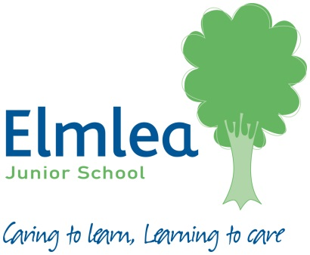
This is the National Curriculum list of spellings for years 3 and 4 that all children are expected to know by the end of year 4.
Your child will be taught the appropriate spelling rules and patterns for these words. They may also appear in spelling lists for homework, however please encourage and support your child in learning these words throughout the year.
Word List – Years 3 and 4
accident(ally) | early | knowledge | purpose
actual(ly) | earth | learn | quarter
address | eight/eighth | length | question
answer | enough | library | recent
appear | exercise | material | regular
arrive | experience | medicine | reign
believe | experiment | mention | remember
bicycle | extreme | minute | sentence
breath | famous | natural | separate
breathe | favourite | naughty | special
build | February | notice | straight
busy/business | forward(s) | occasion(ally) | strange
calendar | fruit | often | strength
caught | grammar | opposite | suppose
centre | group | ordinary | surprise
century | guard | particular | therefore
certain | guide | peculiar | though/although
circle | heard | perhaps | though
complete | heart | popular | through
consider | height | position | various
continue | history | possess(ion) | weight
decide | imagine | possible | woman/women
describe | increase | potatoes
different | important | pressure
difficult | interest | probably
disappear | island | promise

