**100 Books To Try And Read In Year 3/4**

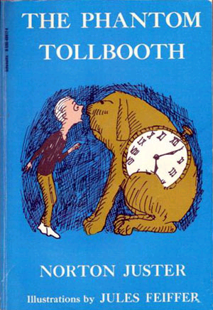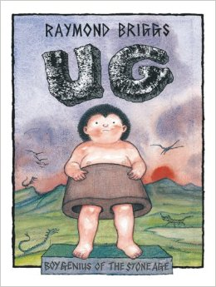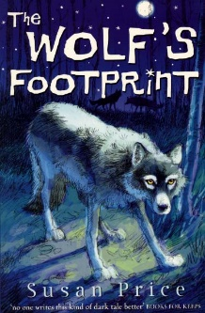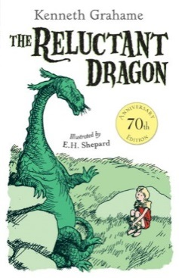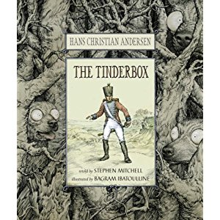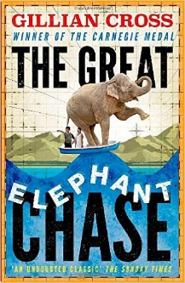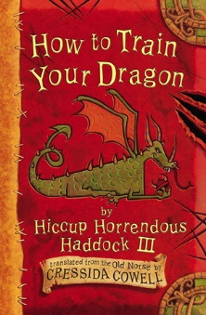

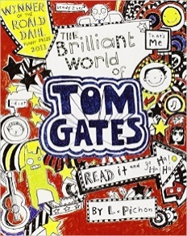

A World of Information

Richard Platt

Tales Of A Fourth Grade Nothing

Judy Blume

The Boy Who Biked The World

Alastair Humphreys

I Am Not A Loser

The Cat In The Hat

Dr Seuss

The Sandwich Thief

Andre Marois

Fantastically Great Women Who Changed The World

Kate Pankhurst

The Sticky Witch

Hillary Mckay

The Reluctant Dragon

Kenneth Grahame

The Moonshine Dragon

Cornelia Funke

The Brilliant World of Tom Gates

Liz Pichon

Liz Pichon

Secrets According to Humphrey

Betty G. Birney

The Adventures of Captain Underpants

Dav Pilkey

You’re A Bad Man Mr Gum!

Andy Stanton

Erica’s Elephant

Sylvia Bishop

The Phantom Tollbooth

Norton Juster

How to Train Your Dragon

Cressida Cowell

The Wolf’s Footprint

Susan Price

The Tinderbox

Hans Christian Andersen

Ug: Boy Genius of the Stone Age

Raymond Briggs

The Great Elephant Chase  
  
Gillian Cross

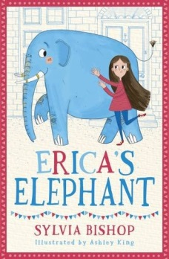

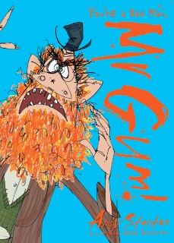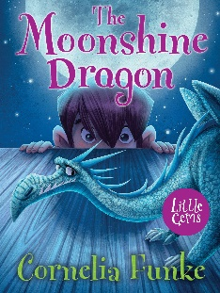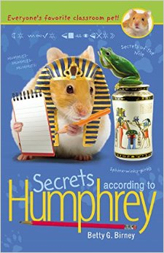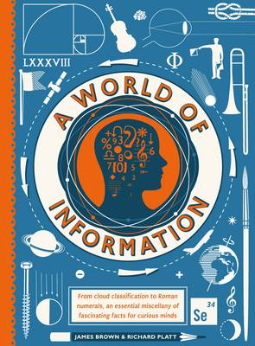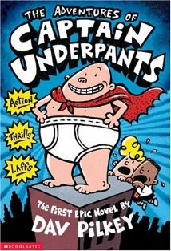

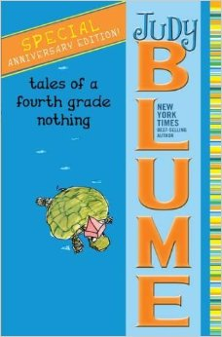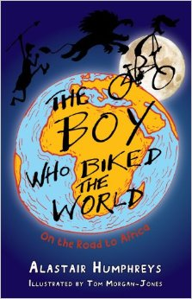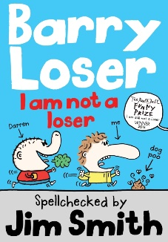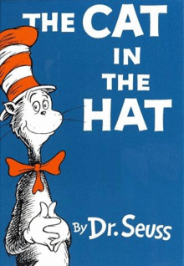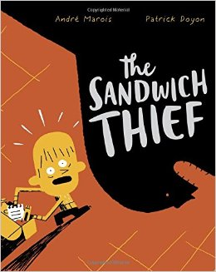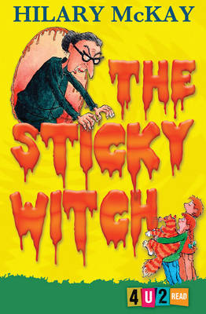

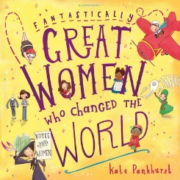

**100 Books To Read In Year 3 and 4**

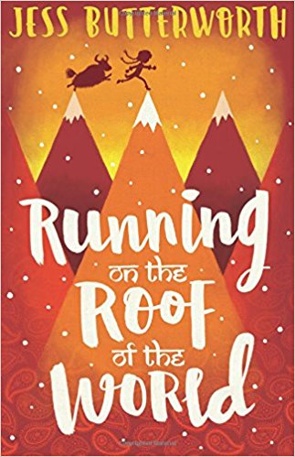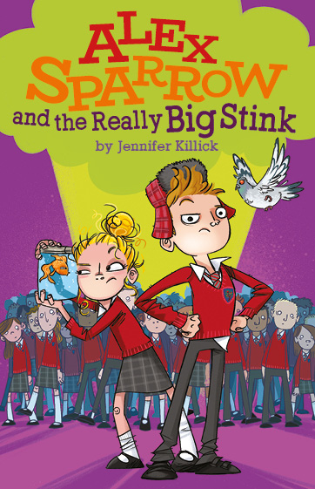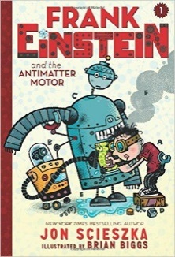 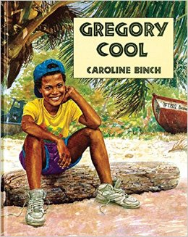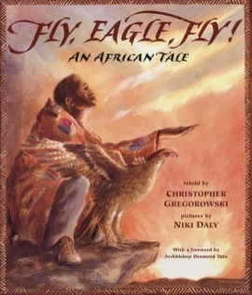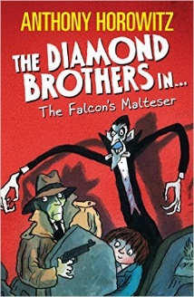

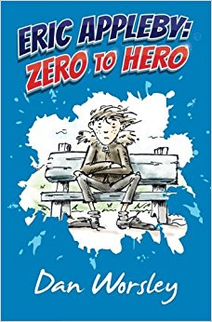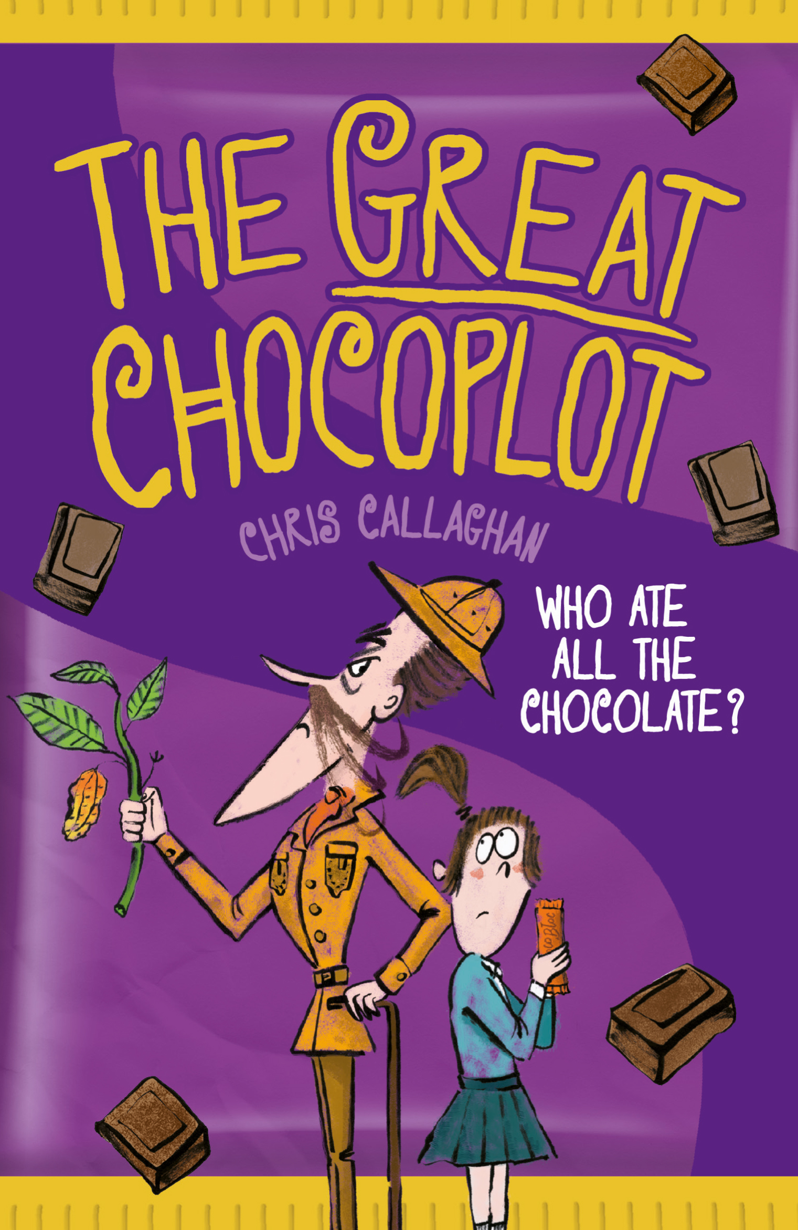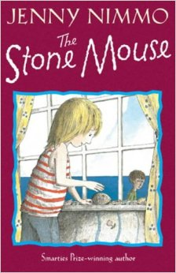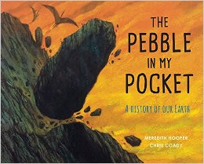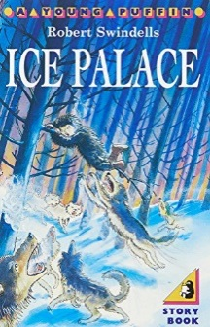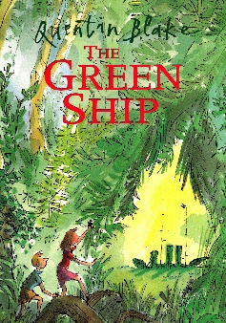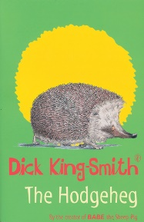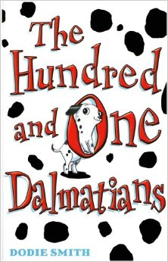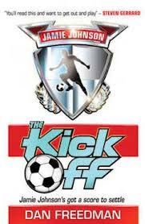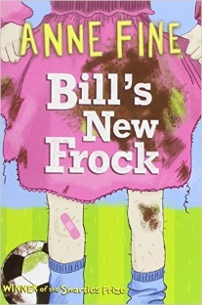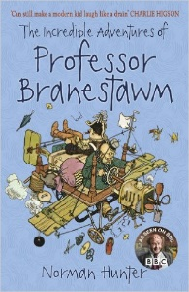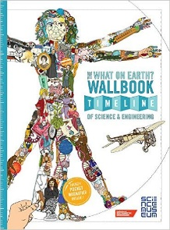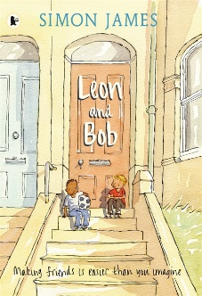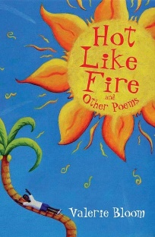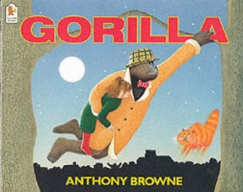**v**

The What On Earth Wallbook

Christopher Lloyd

The Stone Mouse

Jenny Nimmo

The Pebble in my Pocket

Meredith Hooper

Ice Palace

Robert Swindells

The Hodgeheg

Dick King-Smith

The Green Ship

Quentin Blake

The Hundred and One Dalmatians

Dodie Smith

The Kick Off

Dan Freedman

Fly, Eagle Fly!

Christopher Gregorowski

Flour Babies

Anne Fine

The Incredible Adventures of Professor Branestawn

Norman Hunter

Eric Appleby: Zero to Hero  
Dan Worsley

The Great Chocoplot

Chris Callaghan

Leon and Bob

Simon James

Hot Like Fire

Valerie Bloom

Frank Einstein and the Antimatter Motor

Jon Sciezka

Running On The Roof Of The World

Jess Butterworth

Gregory Cool

Caroline Birch

Gorilla

Anthony Browne

The Falcon’s Malteser

Anthony Horowitz

Alex Sparrow and the Really Big Stink

Jennifer Killick

**100 Books To Read In Year 3 and 4**

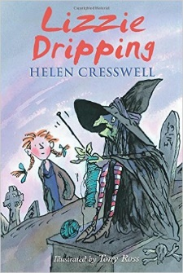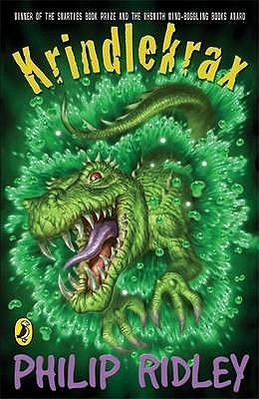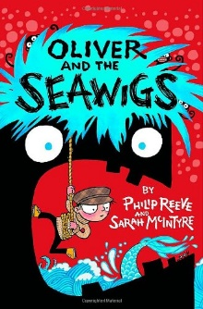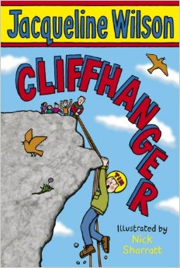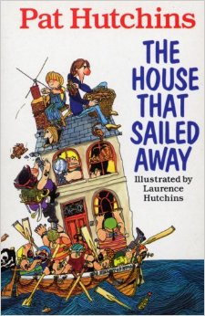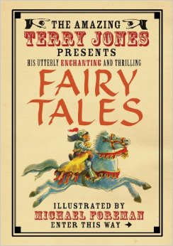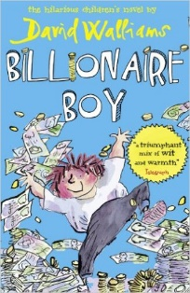

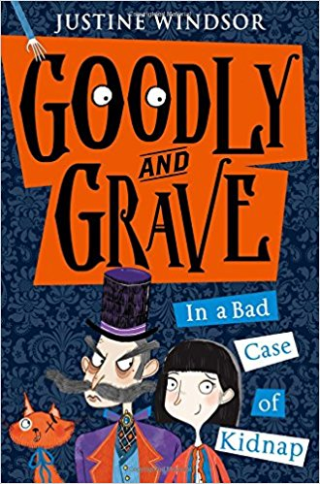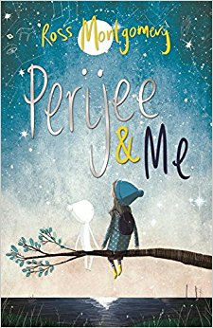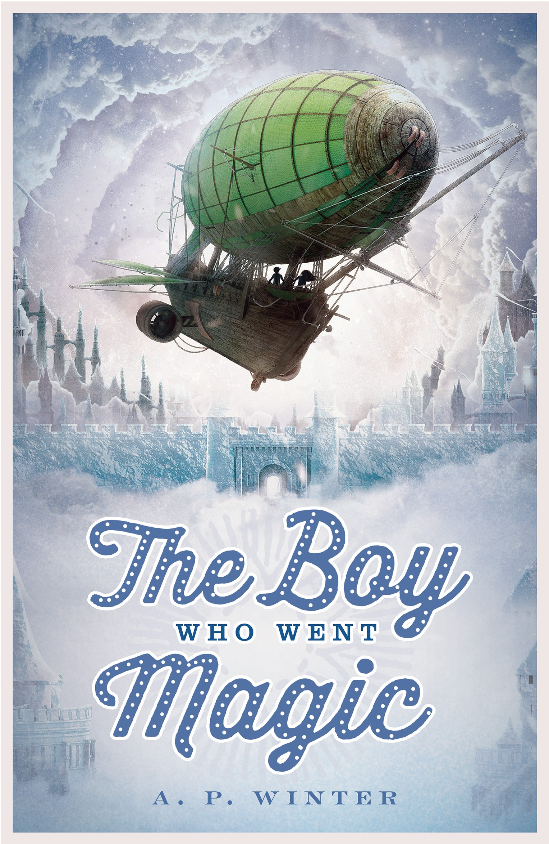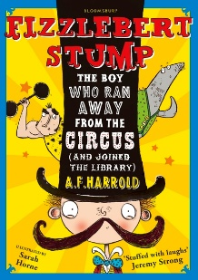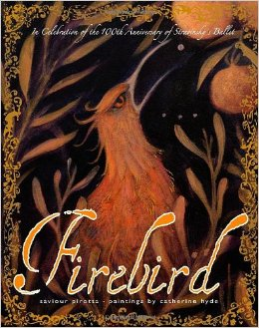 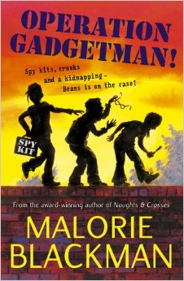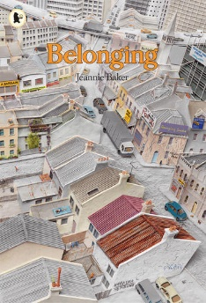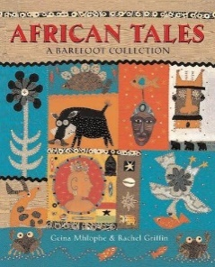 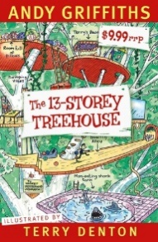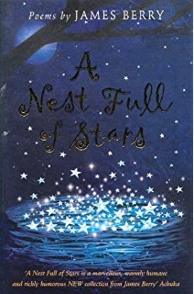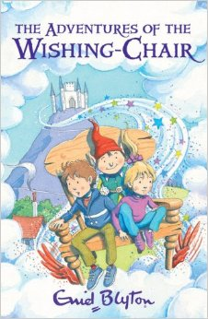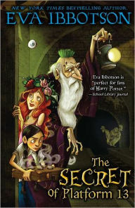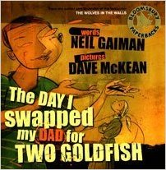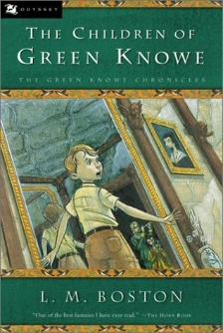

The Adventures of the Wishing-Chair

Enid Blyton

The Imaginary

A F Harold

Firebird

Saviour Pirotta

The Boy Who Went Magic

AP Winters

Operation Gadgetman!

Malorie Blackman

Belonging

Jeannie Baker

African Tales: A Barefoot Collection

GcinaMlophe

Goodly and Grave

Justine Windsor

The House That Sailed Away

Pat Hutchins

The 13-Storey Treehouse

Andry Griffiths

Perijee and Me

Ross Montgomery

A Nest Full of Stars

James Berry

The Secret of Platform 13

Eva Ibbotson

The Day I Swapped My Dad for Two Goldfish

Neiil Gaiman

The Children of Green Knowe

L.M.Boston

Lizzie Dripping

Helen Cresswel

Krindlekrax

Philip Ridley

Oliver and the Seawigs

Phillip Reeve

Cliffhanger

Jacqueline Wilson

Fairy Tales

Terry Jones

Billionaire Boy

David Walliams

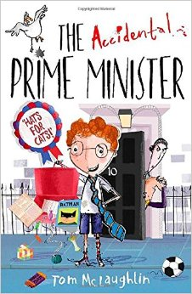**100 Books To Try And Read In Year 3/4**

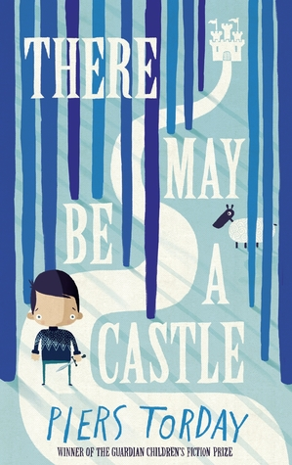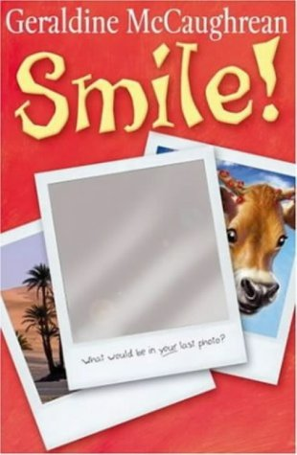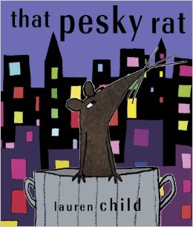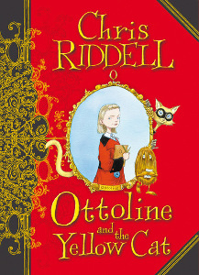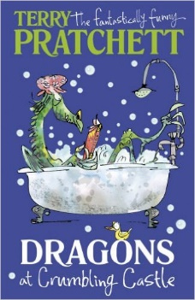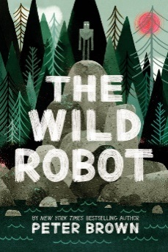

Shackleton’s Journey

William Grill

The Whisperer

Nick Butterworth

The Tale of Despereaux

Kate DiCamillo

Dragons at Crumbling Castle

Terry Pratchett

Fergus Crane

Paul Stewart and Chris Riddell

The Year of Billy Miller

Kevin Henkes

Liz Pichon

Frindle

Andrew Clements

The Shrimp

Emily Smith

The Invention of Huge Cabret

Brian Selznick

Mouse Noses on Toast

Darren Fletcher

There May Be A Castle

Piers Torday

That Pesky Rat

Lauren Child

Smile

Geraldine McCaughrean

Ottoline and the Yellow Cat

Chris Riddell

The Wild Robot

Peter Brown

The Accidental Prime Minister

Tom McLaughlin

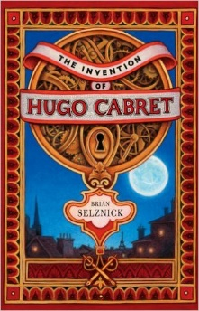

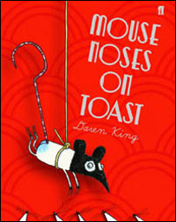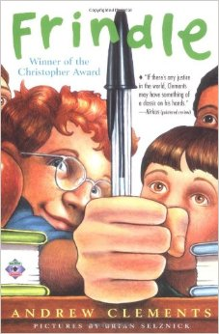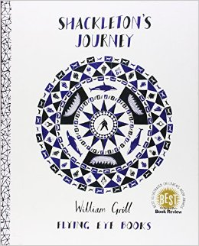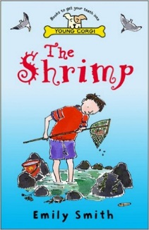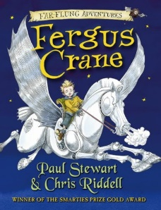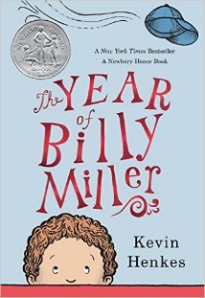

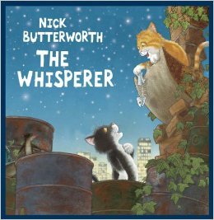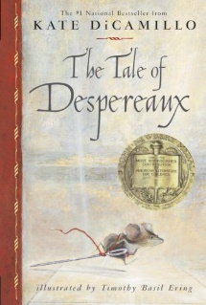

**100 Books To Read In Year 3 and 4**

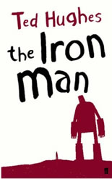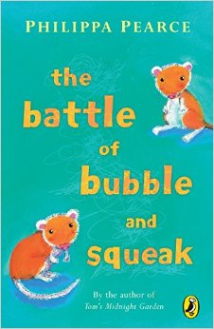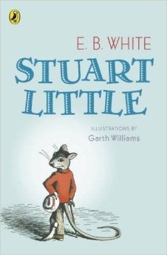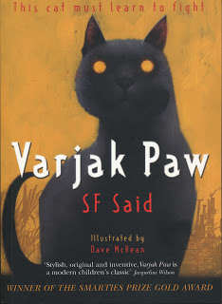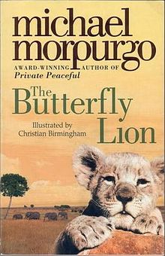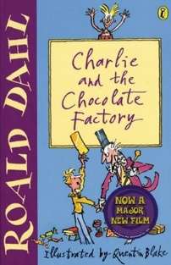

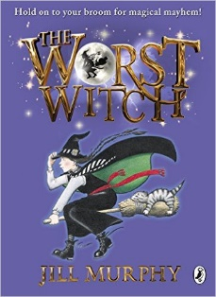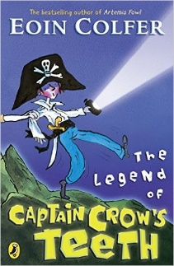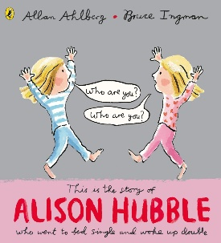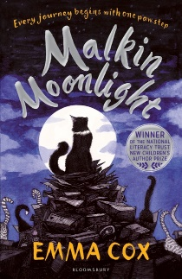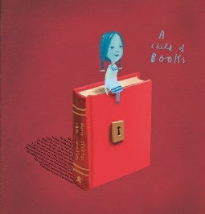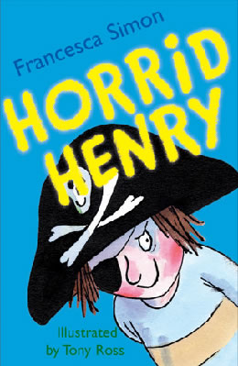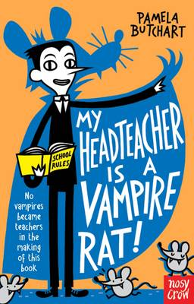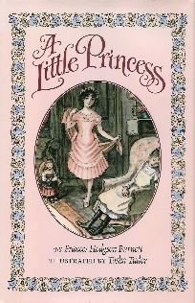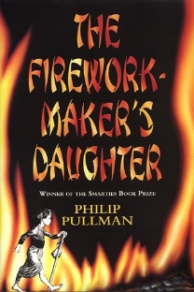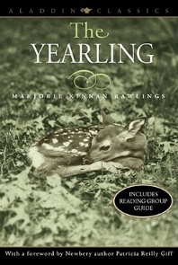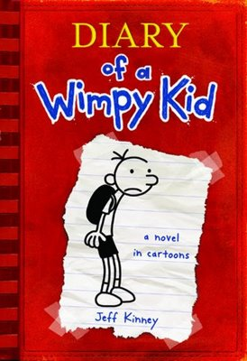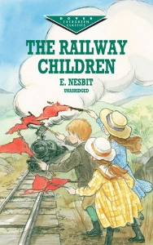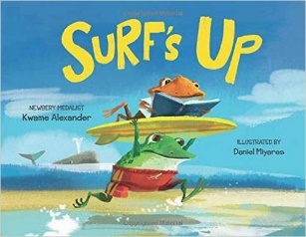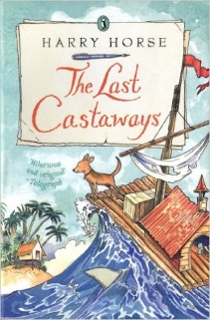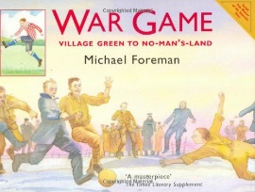

War Game

Michael Foreman

The Worst Witch

Jill Murphy

The Legend of Captain Crow’s Teeth

Eoin Colfer

Alison Hubble

Allan Ahlberg and Bruce Ingham

Malkin Moonlight

Emma Cox

A Child Of Books

Oliver Jeffers

Horrid Henry

Francesca Simon

My Headteacher is a Vampire Rat

Pamela Butchart

The Iron Man

Ted Hughes

A Little Princess

Frances Hodgson Burnett

The Firework-Maker’s Daughter

Phillip Pullman

The Yearling

Marjorie Kinnan Rawlings

The Railway Children

E Nesbit

Diary Of A Wimp Kid

Jeff Kinney

Surf’s Up

Kwame Alexander

The Last Castaways

Harry Horse

The Battle of Bubble and Squeak

Phillips Pearce

Stuart Little

E B White

Varjak Paw

S F Said

The Butterfly Lion

Michael Morpurgo

Charlie and the Chocolate Factory  
Roald Dahl