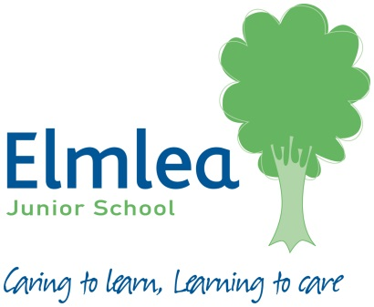
This is the National Curriculum list of spellings for years 3 and 4 that all children are expected to know by the end of year 6.
Your child will be taught the appropriate spelling rules and patterns for these words. They may also appear in spelling lists for homework, however please encourage and support your child in learning these words throughout the year.
Word List – Years 3 and 4
accident(ally) | early | knowledge | purpose
actual(ly) | earth | learn | quarter
address | eight/eighth | length | question
answer | enough | library | recent
appear | exercise | material | regular
arrive | experience | medicine | reign
believe | experiment | mention | remember
bicycle | extreme | minute | sentence
breath | famous | natural | separate
breathe | favourite | naughty | special
build | February | notice | straight
busy/business | forward(s) | occasion(ally) | strange
calendar | fruit | often | strength
caught | grammar | opposite | suppose
centre | group | ordinary | surprise
century | guard | particular | therefore
certain | guide | peculiar | though/although
circle | heard | perhaps | though
complete | heart | popular | through
consider | height | position | various
continue | history | possess(ion) | weight
decide | imagine | possible | woman/women
describe | increase | potatoes
different | important | pressure
difficult | interest | probably
disappear | island | promise

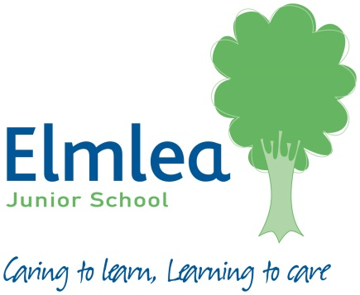
Word List – Years 5 and 6
Accommodate  accommodation | embarrass | persuade
accompany | environment | physical
according | equip (ped, -ment) | privilege
aggressive | especially | privilege
aggressive | exaggerate | profession
amateur | excellent | programme
ancient | existence | pronunciation
apparent | explanation | queue
appreciate | familiar | recognise
attached | foreign | recommend
available | forty | relevant
average | frequently | restaurant
awkward | government | rhyme
bargain | guarantee | rhythm
bruise | harass | sacrifice
category | hindrance | secretary
cemetery | identity | shoulder
committee | immediate(ly) | signature
communicate | individual | sincere(ly)
community | interfere | soldier
competition | interrupt | stomach
conscience | language | sufficient
conscious | leisure | suggest
convenience | marvellous | system
correspond | mischievous | temperature
criticise (critic + ise) | muscle | thorough
curiosity | necessary | twelfth
definite | neighbour | variety
desperate | nuisance | vegetable
determined | occupy | vehicle
develop | occur | yacht
dictionary | opportunity
disastrous | parliament

