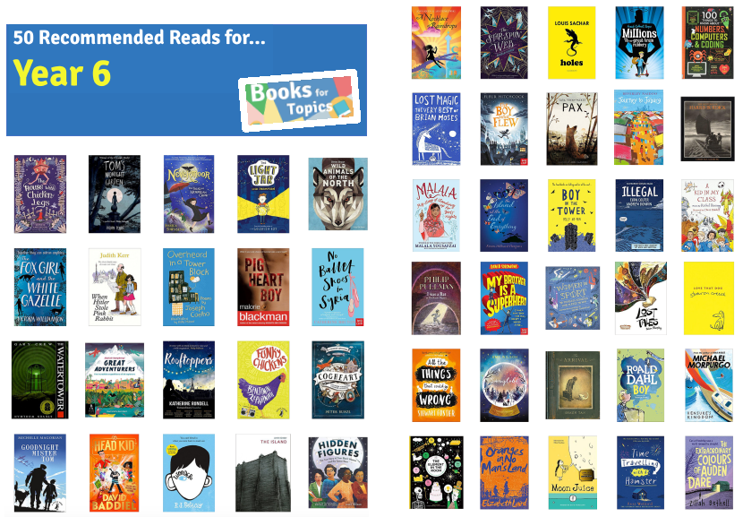

**100 Books To Read In Year 5 and 6**

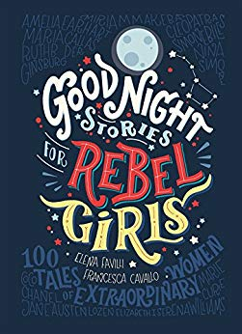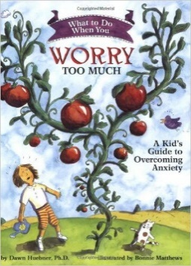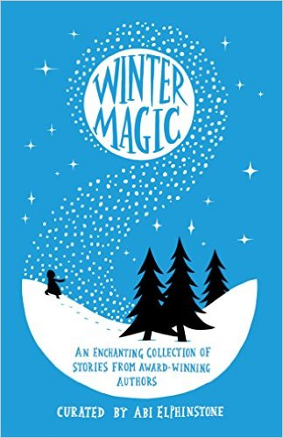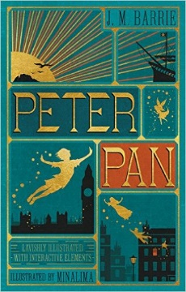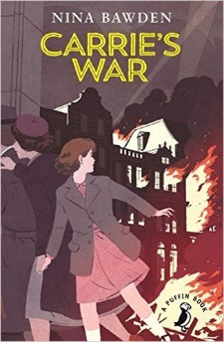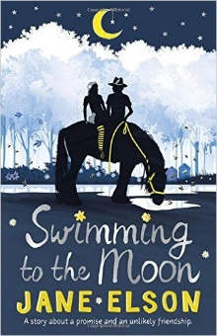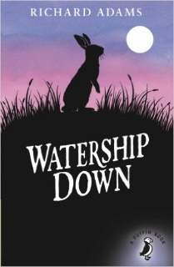

Skullduggery Pleasant

Derek Landy

The Wonderful Wizard of Oz

L Frank Baum

The Miraculous Journey of Edward Tulane

Kate DiCamillo

Carrie’s War

Nina Bawden

The Goldfish Boy

Lisa Thompson

101 Poems for Children

Carol Ann Duffy

Liz Pichon

Howl’s Moving Castle

Diana Wynne Jones

There May Be A Castle

Piers Toarday

The Invention of Huge Cabret

Brian Selznick

What to Do When You Worry Too Much

Dawn Huebner

Winter Magic  
  
Stories by Various Authours

Peter Pan

JM Barrie

Swimming to the Moon

Jane Eslson

Watership Down

Richard Adams

Goodnight Stories For Rebel Girls

Elena Favilli and Francesca Cavallo

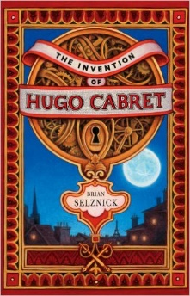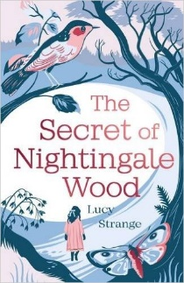

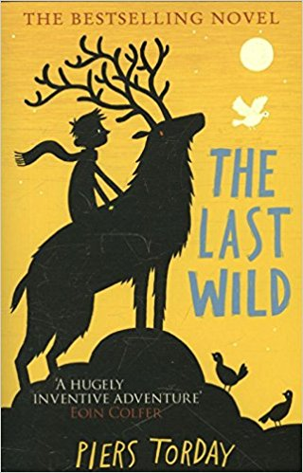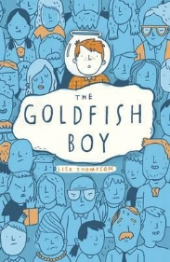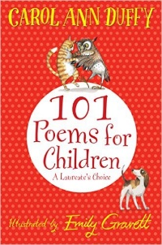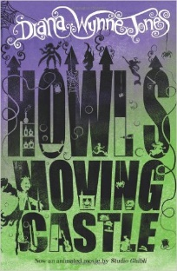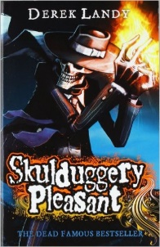

The Secret of Nightingale Wood

Lucy Strange

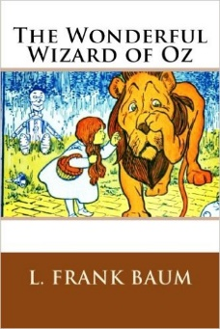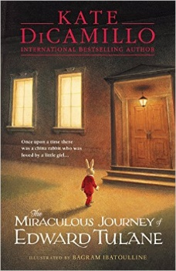

**100 Books To Read In Year 5 and 6**

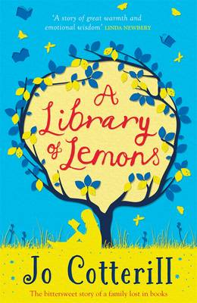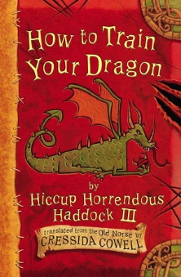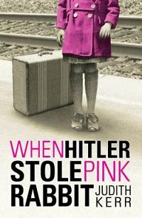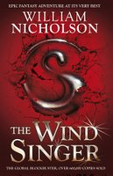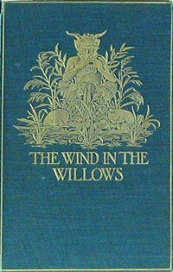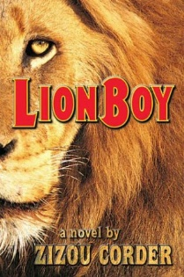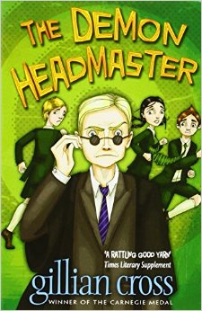

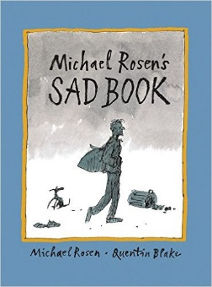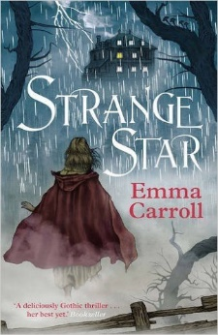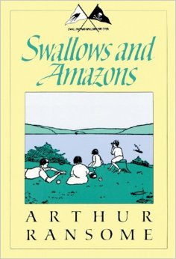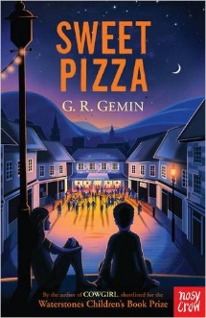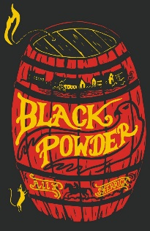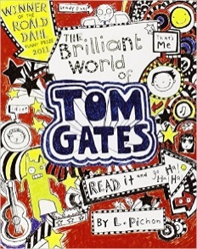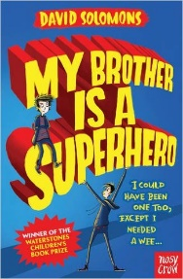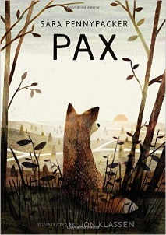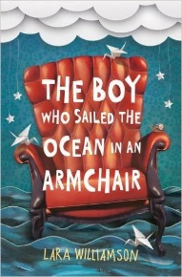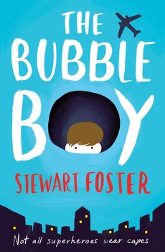

Pax

Sara Pennypacker

Ballet Shoes

Noel Streatfeild

The Arrival

Shaun Tan

Sad Book

Michael Rosen

A Long Walk To Water

Linda Sue Park

Strange Star

Emma Carrooll

Swallows and Amazons

Arthur Ransome

Sweet Pizza

G R Gremin

The Wind in the Willows

Kenneth Grahame

Black Powder

Ally Sherrick

The Brilliant World of Tom Gates

Liz Pichon

Liz Pichon

My Brother is a Superhero

David Solomons

The Boy Who Sailed the Ocean in an Armchair

Lara Williamson

The House With Chicken Legs

Sophie Anderson

The Bubble Boy

Stewart Foster

A Library of Lemons

Jo Cotterill

How to Train Your Dragon

Cressida Cowell

When Hitler Stole Pink Rabbit

Judith Kerr

The Wind Singer

William Nicholson

LionBoy

Zizou Corder

The Demon Headmaster  
  
Gillian Cross

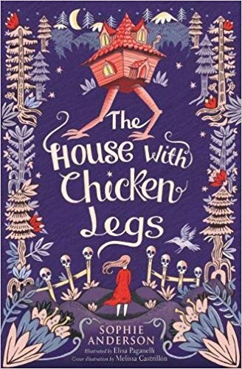

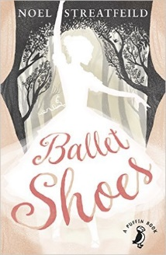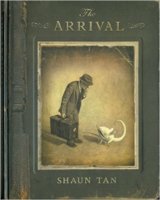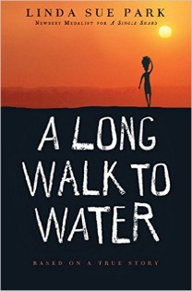

**100 Books To Try And Read In Year 5 and 6**

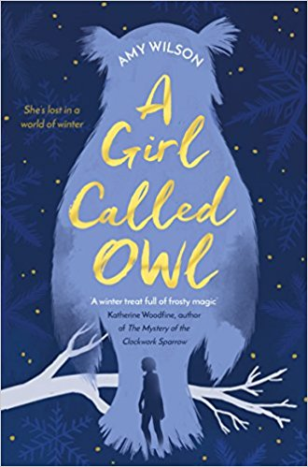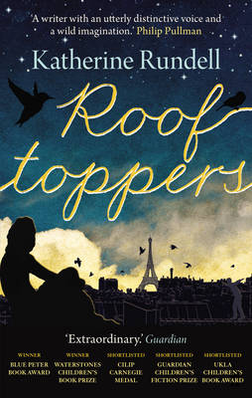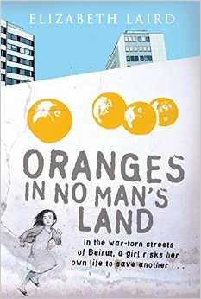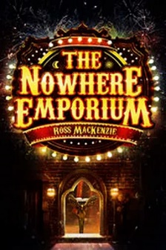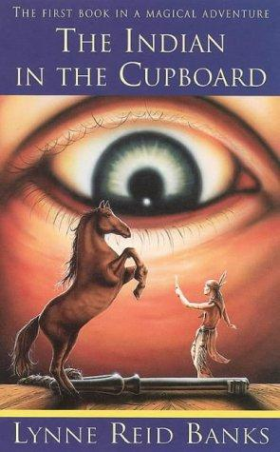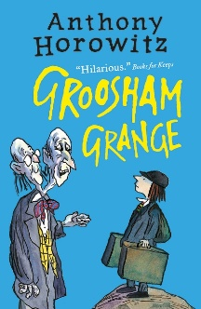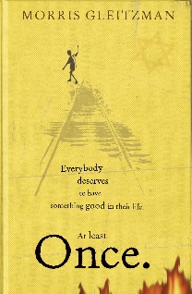

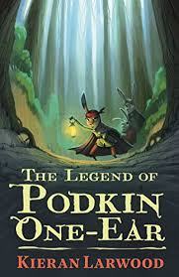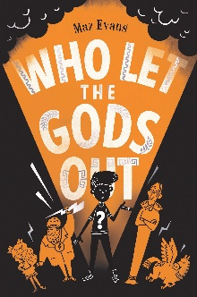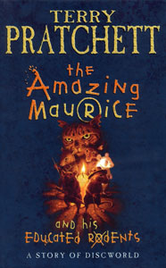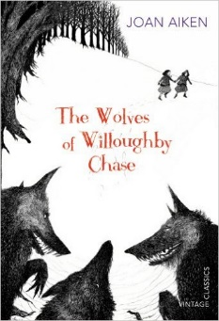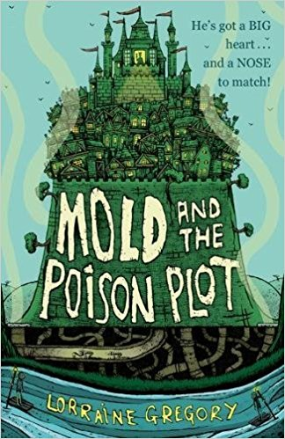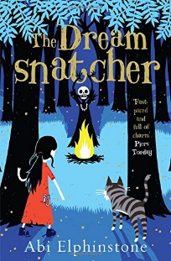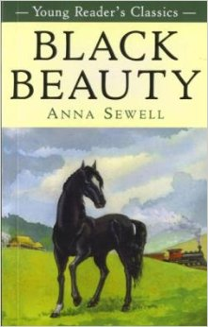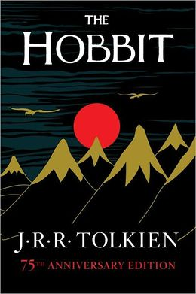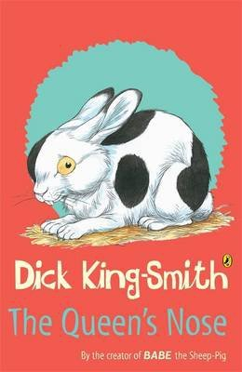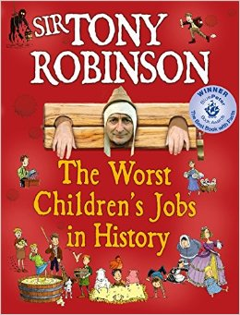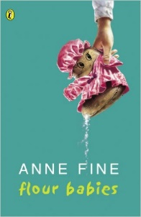 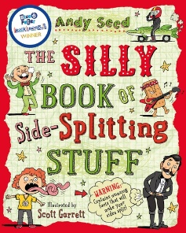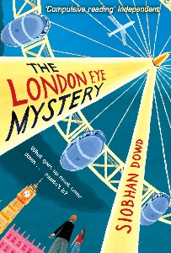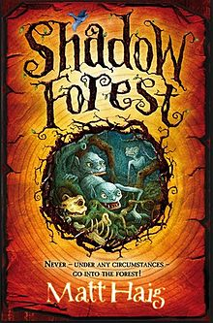

Who Let The Gods Out?  
Maz Evans

The Amazing Maurice and his Educated Rodents

Terry Pratchett

The Wolves of Willoughby Chase

Joan Aiken

The Silly Book of Side-Splitting Stuff

Andy Seed

Black Beauty

Anna Sewell

The Hobbit

JRR Tolkien

The Queen’s Nose

Dick King-Smith

The Worst Children’s Jobs In History

Tony Robinson

The Indian In The Cupboard

Lynne Reed Banks

Flour Babies

Anne Fine

Mold and the Poison Plot

Lorraine Gregory

The Dreamsnatcher

Abi Elphinstone

The London Eye Mystery

Siobhan Dowd

The Legend of Podkin One Ear

Kieran Larwood

Shadow Forest

Matt Haig

A Girl Called Owl

Amy Wilson

Rooftoppers

Katherine Rundell

Oranges in No Man’s Land

Elizabeth Laird

The Nowhere Emporium

Ross Mackenzie

Groosham Grange

Anthony Horowitz

Once

Morris Gleitzmann

**100 Books To Read In Year 5 and 6**

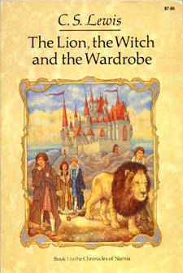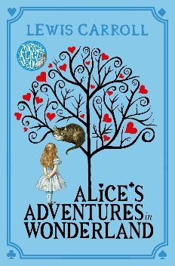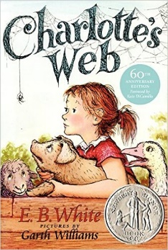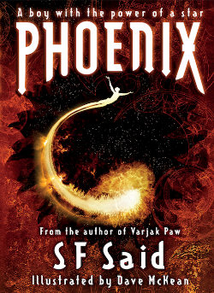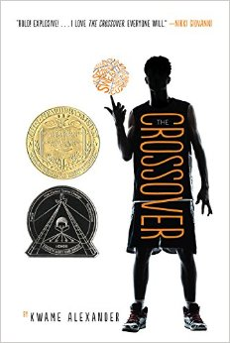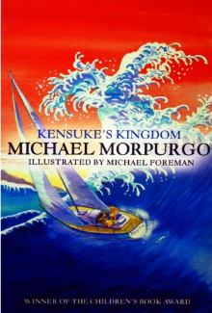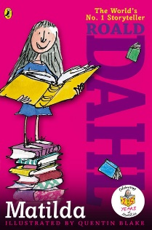

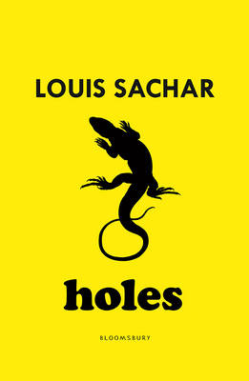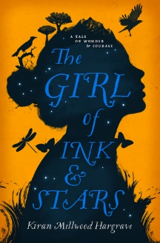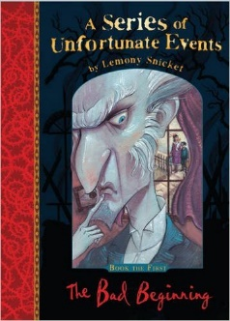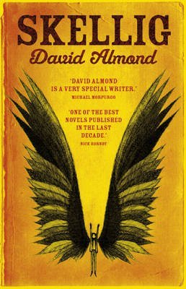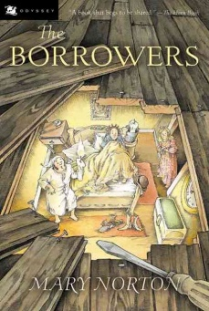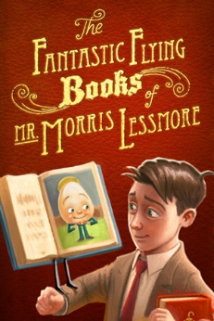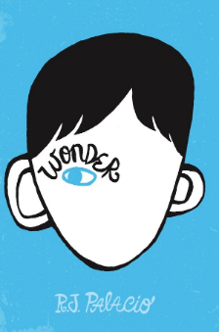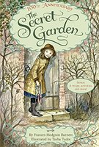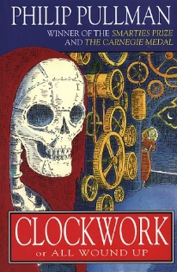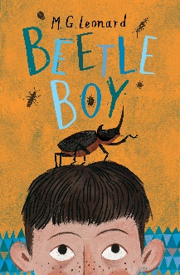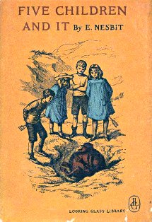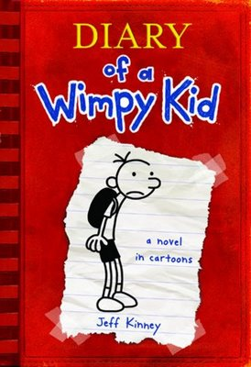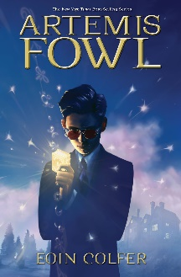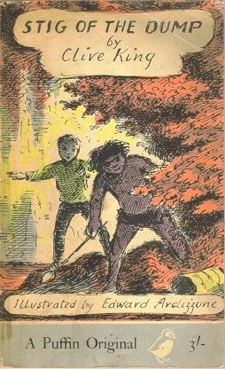

Holes

Louis Sachar

The Girl of Ink and Stars

Kiran Millwood Hargraves

A Series of Unfortunate Events

Lemony Snickett

Skellig

David Almond

The Fantastic Flying Books of Mr Morris Lessmore

William Joyce

The Borrowers

Mary Norton

Wonder  
RJ Palacio

The Crossover

Kwame Alexander

The Secret Garden

Frances Hodgson Burnett

Clockwork

Phillip Pullman

Beetle Boy

M G Leonard

Five Children and It

E Nesbit

Diary Of A Wimp Kid

Jeff Kinney

Artemis Fowl

Eoin Colfer

Stig Of The Dump

Clive King

The Lion, The Witch and The Wardrobe

C S Lewis

Alice’s Adventures In Wonderland

Lewis Carroll

Charlotte’s Web

E B White

Phoenix

S F Said

Kensuke’s Kingdom

Michael Morpurgo

Matilda  
Roald Dahl

**100 Books To Read In Year 5 and 6**

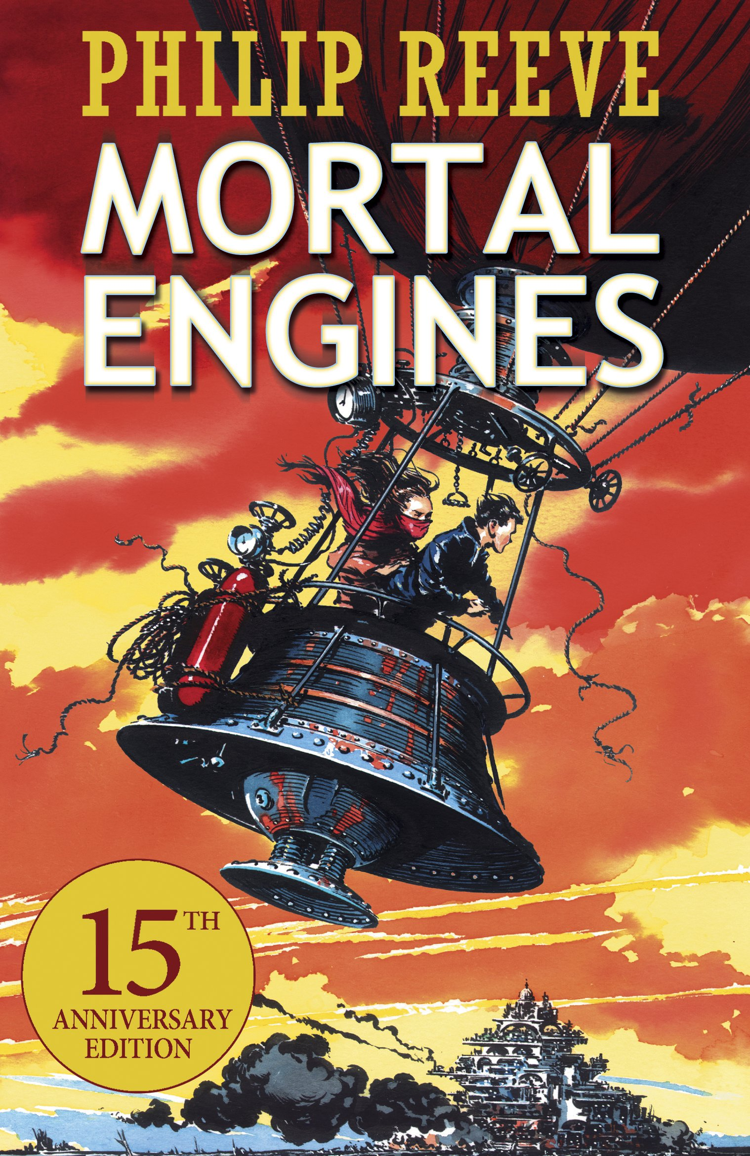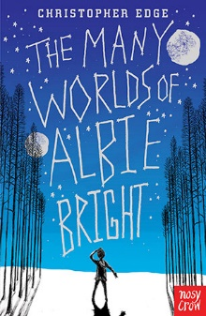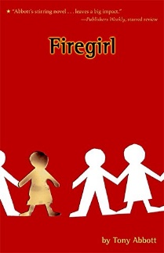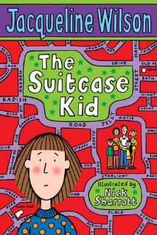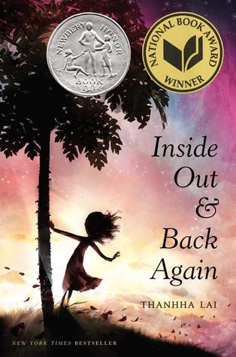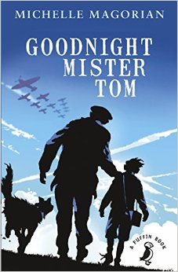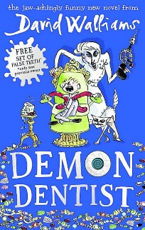

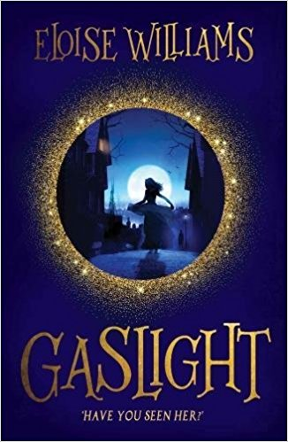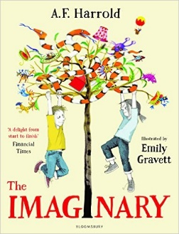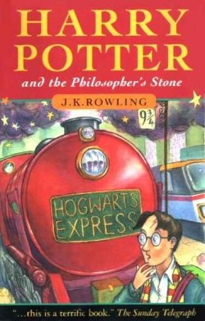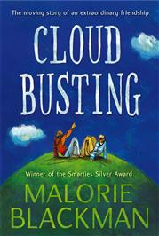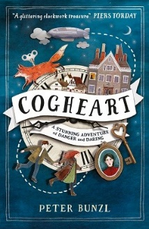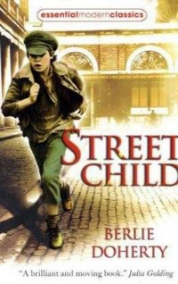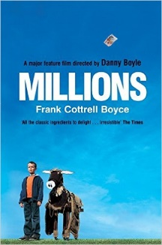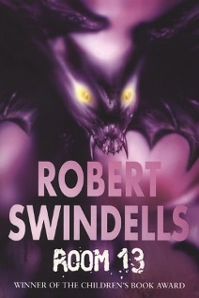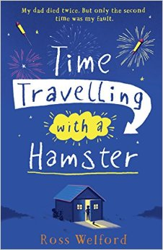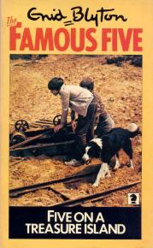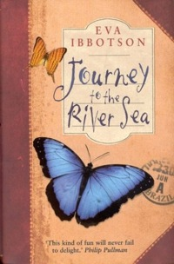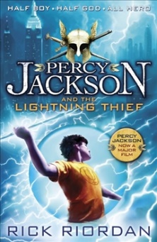v

Five On A Treasure Island

Enid Blyton

The Imaginary

A F Harold

Harry Potter and the Philosopher’s Stone

JK Rowling

Gaslight

Eloise Williams

Cloud Busting

Malorie Blackman

Cogheart

Peter Bunzl

Street Child

Berlie Doherty

Millions

Frank Cottrell-Boyce

Inside Out and Back Again

Thannha Lai

Kick

Mitch Johnson

Room 13

Robert Swindells

Time Travelling With a Hamster

Ross Welford

Journey to the River Sea

Eva Ibbotson

The Graveyard Book

Neil Gaiman

Percy Jackson and the Lightning Thief

Rick Riordan

The Many Worlds of Albie Bright

Christopher Edge

Firegirl

Tony Abbott

Mortal Engines

Philip Reeve

The Suitcase Kid

Jacqueline Wilson

Goodnight Mister Tom

Michelle Magorian

Demon Dentist

David Walliams

